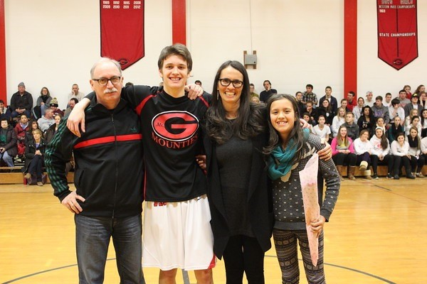
I’m Karen Shepard, and I’d like to introduce myself and tell you a little about why I’m running for Planning Board.
I’ve been back in town for twenty-five years (I graduated from Williams in 1987) and my husband Jim and I have raised our kids here and sent them to the town’s public schools. I’m a novelist and a teacher and have been involved in the community in a variety of ways: I was co-president of the ABC House board; I’ve been active at Mount Greylock with the PTO, and on a variety of search committees, and on the building project there. At Williams, I served on the building committees for the Bookstore and The Log renovation, and I chaired the Bookstore committee, all of which taught me about what needs to go into development of that kind.
After the election last November, I encouraged my students and kids to get involved, and told them that it’s not just our right but our responsibility to take part in how our communities are shaped. Now I figure it’s time to practice what I preach.
I think to get involved, you just have to be the kind of person who wants to listen and learn. You have to have common sense; you have to have the energy to try to make things happen, and, most importantly, it seems to me, you have to be able to put yourself in other people’s shoes. You have to listen to what everyone thinks they want and need, and then have open, honest, and civil discussions, and figure out first what needs to be done and second how to roll up your sleeves and do it.
Here’s some of what I’ve come to believe:
•The Planning Board Should Represent the Town. The Planning Board should represent and support the town’s vision for the future of our community; individual agendas should not outweigh public vision.
•The Town’s Vision is an Achievable Vision. Economic development, encouraging growth, and the protection of open space can work with not against each other.
•We Need Flexible Residential Areas. Increasing the flexibility of residential areas through high density, mixed-income, multi-family, and affordable housing, and modified zoning in concentrated areas will promote a vibrant, populated residential center that will energize not just the tourist trade, but the local residents’ day-to-day life, and will also care for our growing elderly population and attract younger residents to town.
•Concentrated Development is Good Development. Concentrated development reduces sprawl, allowing for the protection of our valued natural resources in larger parcels on the outskirts of town. We need zoning that encourages sustainable high-density, mixed-use development in certain districts.
•Protecting Open Space is Pro-development. It increases the value of abutting lots; it attracts tourists; protecting open space on the outskirts of town encourages development at the center.
•An Educated Town is a More Prosperous Town. Did you know, for example, that although our town is 83% open space, only 29% of that is protected, the smallest percentage among eight Northern Berkshire towns? Or that when you apply absolute and partial constraints to the Limited Industrial and Planned Business districts, the amount of land available to develop more or less disappears? The more we know, the more we can achieve.
•We Need Change on the Planning Board. A town is only as strong as the number of people involved in the way it’s run. Too often the same handful of people fill the same local government positions. The incumbent has been on the Planning Board for ten years. Someone who isn’t as familiar with “the way things have always been done” can bring fresh eyes to old problems.
If what I believe sounds like what you believe, I hope you’ll give me a chance to represent your values, to represent your desires, a chance to serve you in ways that make this town as strong as it can possibly be. The election is May 9th at WES; polls are open 7:00am-8:00pm. I hope to see you there.
Thank you for your time and attention,
Karen Shepard

Email: kshepard@williams.edu
www.karen-shepard.com
Facebook: KarenShepardAuthor
Twitter: @karenlshepard

